Updates to the App

# Documentation

Part one was updated with more references and information to address feedback.

# Folder organization

Code was reworked and moved to ensure each file serves a single purpose, contained in related folders.

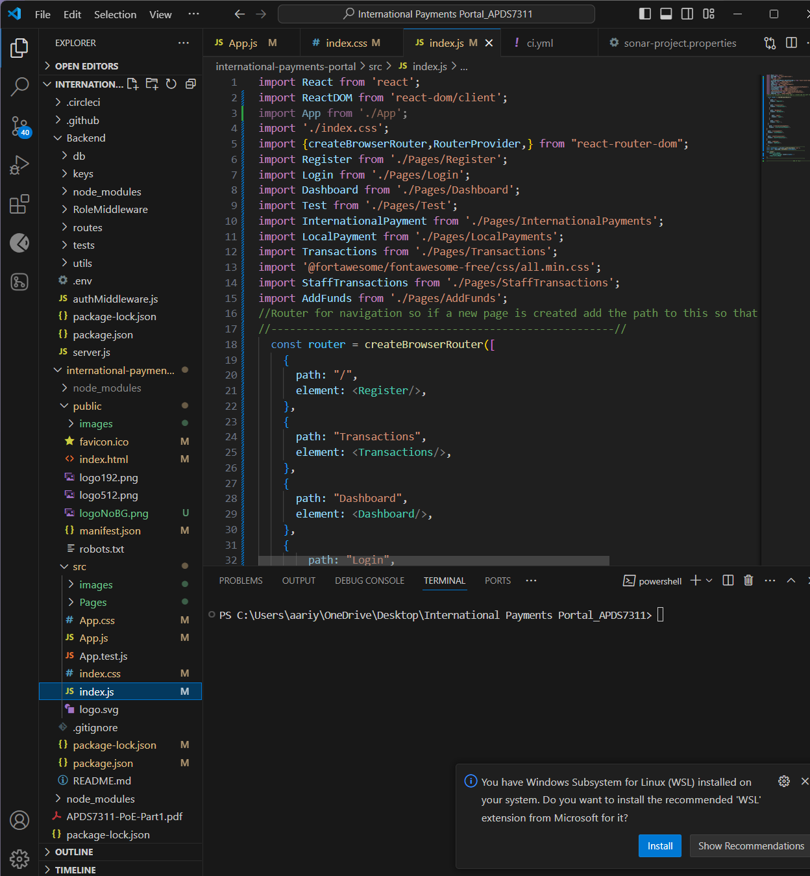

# Pipelines and Tests configured

1. SonarQube

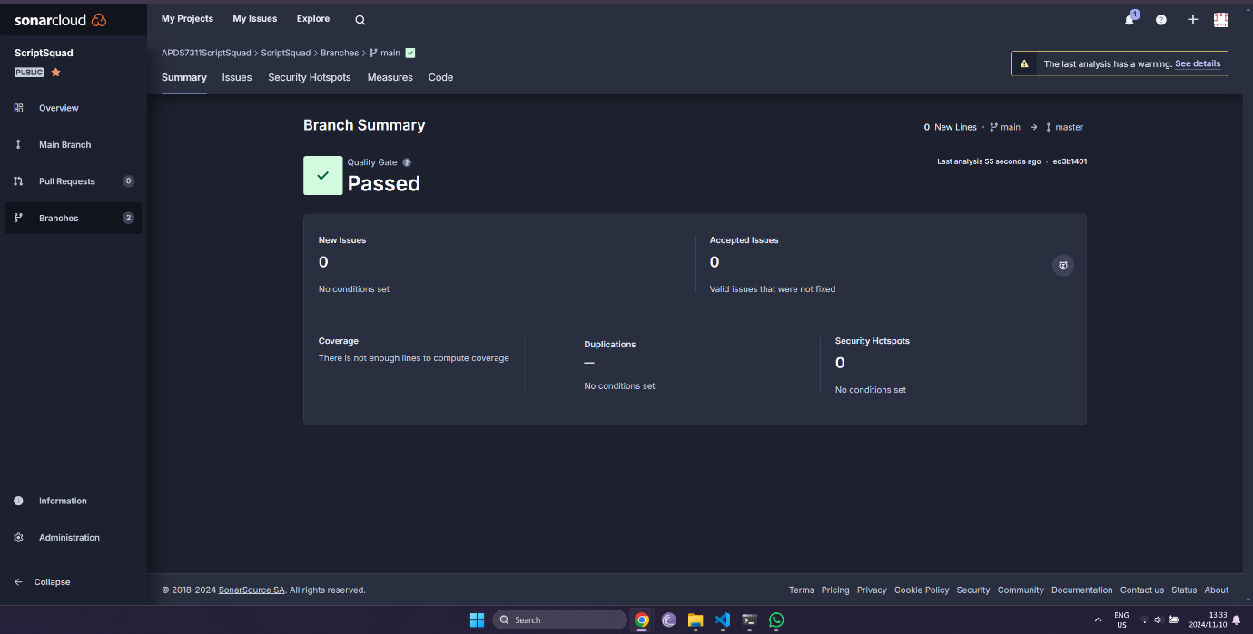

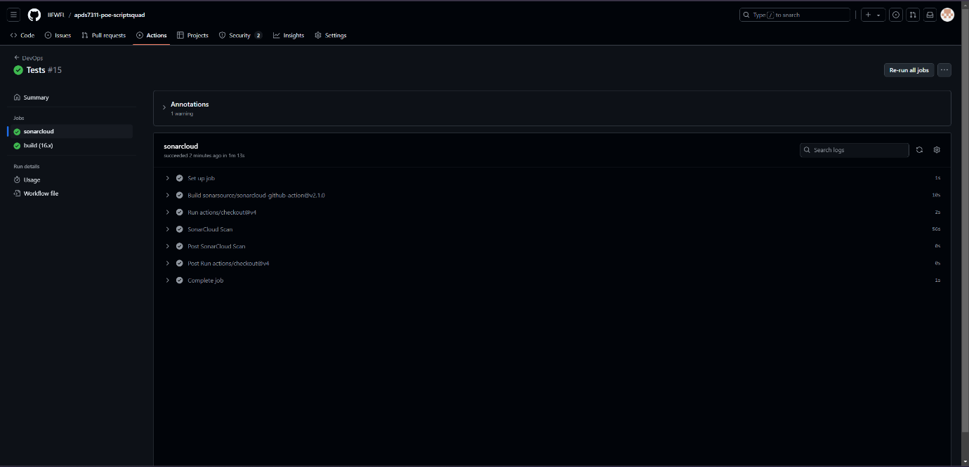

1. CircleCI

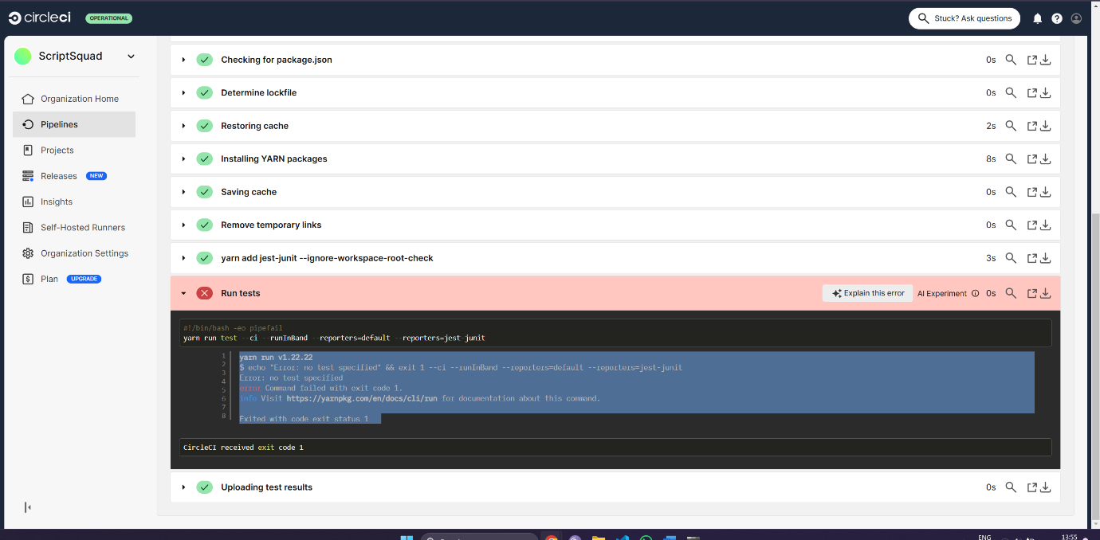

1. Snyk: These vulnerabilities are not addressed to enable testing of the application without a secure certificate from a trusted authority. In development the false would be changed to true.

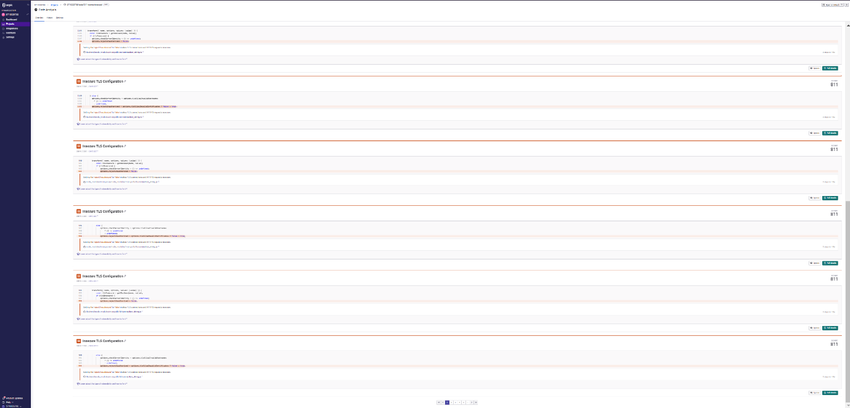

1. Build Pipeline

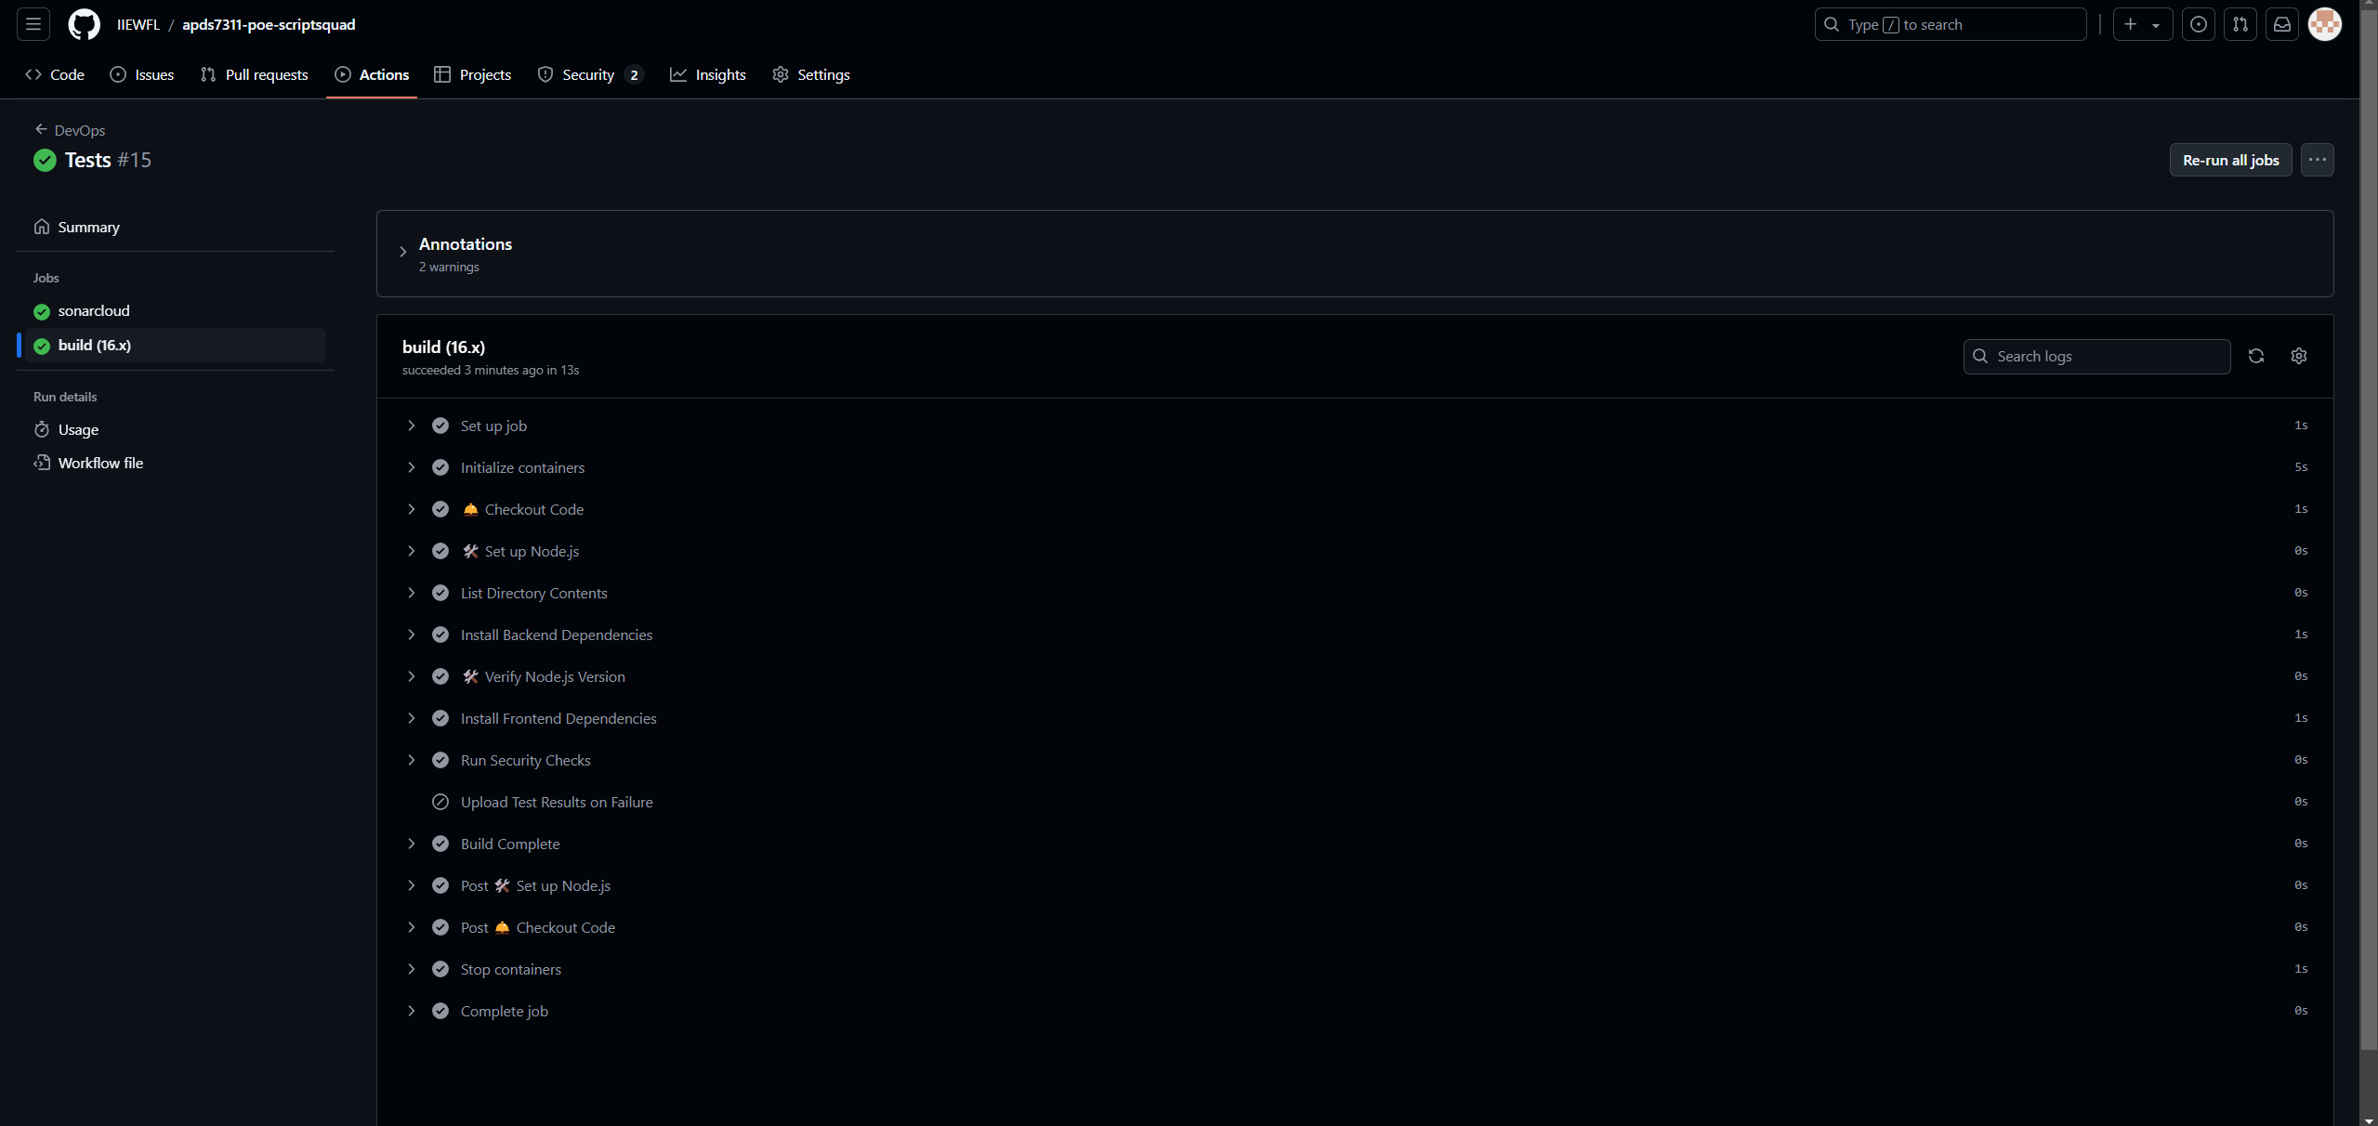

# Code Updates

1. Logging, Error handling and comments were added to all sections of code.
2. Backend tests were added for security.
3. Server no longer directly contains any middleware or models.
4. Helmet and Morgan configured for security and logging purpose.
5. Created and added image assets for UI.
6. Error messages for users on UI.
7. ValidationChecks class: Regex for any user entered information.
8. authMiddleware class: Use of JWT Tokens
9. Hashing and Salting of password using bcrypt
10. Account numbers securely generated using crypto.randomInt